**EXP 6:- Implement program to apply moving average smoothing for data preparation and time series forecasting**

**AIM:**

To apply **moving average smoothing** on the **RANK** column over **YEAR** to reduce fluctuations and observe trends in the data.

**ALGORITHM:**

**Step 1: Load the Dataset**

* Import the necessary libraries (pandas, matplotlib).
* Read the dataset (trends.csv).

**Step 2: Preprocess the Data**

* Ensure the dataset has YEAR and RANK columns.
* Sort the dataset by YEAR to maintain chronological order.

**Step 3: Apply Moving Average Smoothing**

* Compute a **5-year Simple Moving Average (SMA)** for RANK.
* Compute a **5-year Exponential Moving Average (EMA)** for RANK.

**Step 4: Plot and Visualize the Data**

* Plot RANK, SMA_5, and EMA_5 over YEAR.
* Invert the y-axis (assuming a lower rank is better).

**Step 5: Save the Processed Data**

* Save the new dataset (trends_smoothed.csv) with SMA and EMA values.

**PROGRAM:**

python

CopyEdit

import pandas as pd

import matplotlib.pyplot as plt

# Step 1: Load the dataset

file_path = "/mnt/data/trends.csv"

df = pd.read_csv(file_path)

# Step 2: Preprocess the data

df = df.sort_values(by='YEAR') # Sort by YEAR

# Step 3: Apply Moving Average Smoothing

df['SMA_5'] = df['RANK'].rolling(window=5).mean() # 5-year Simple Moving Average

df['EMA_5'] = df['RANK'].ewm(span=5, adjust=False).mean() # 5-year Exponential Moving Average

# Step 4: Plot and Visualize

plt.figure(figsize=(10, 5))

plt.plot(df['YEAR'], df['RANK'], label="Original Rank", linestyle='dotted', marker='o')

plt.plot(df['YEAR'], df['SMA_5'], label="5-Year SMA", color='red')

plt.plot(df['YEAR'], df['EMA_5'], label="5-Year EMA", color='green')

plt.gca().invert_yaxis() # Invert Y-axis (assuming lower rank is better)

plt.legend()

plt.title("Moving Average Smoothing on Rank Data")

plt.xlabel("Year")

plt.ylabel("Rank")

plt.show()

# Step 5: Save the processed file

output_path = "/mnt/data/trends_smoothed.csv"

df.to_csv(output_path, index=False)

print(f"Smoothed data saved to {output_path}")

**OUTPUT:**

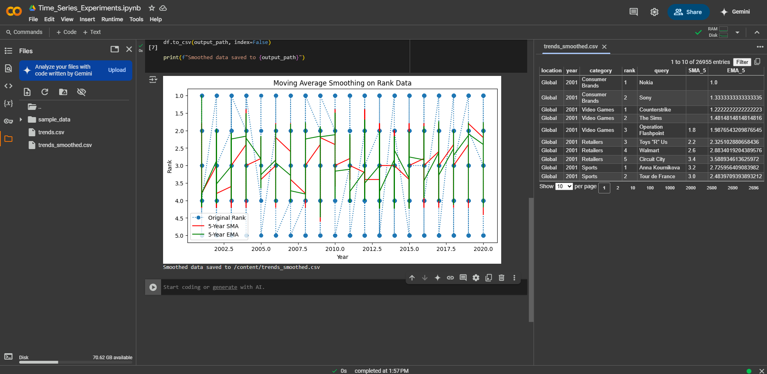

**RESULT:**

Moving average smoothing effectively reduces fluctuations in the **RANK** column over **YEAR**, highlighting overall trends. The **SMA** provides a stable long-term trend, while the **EMA** quickly adapts to recent changes, making trend analysis and forecasting more reliable.